We create the folder **GitDemo,** then execute the commands ->

**COMMANDS:**

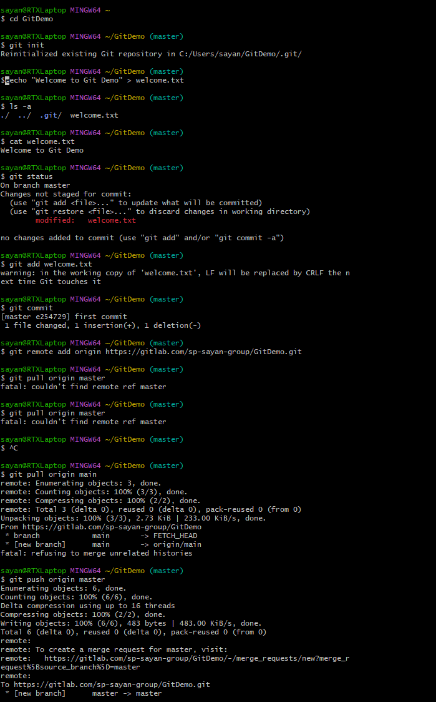

**In GitLab:**

